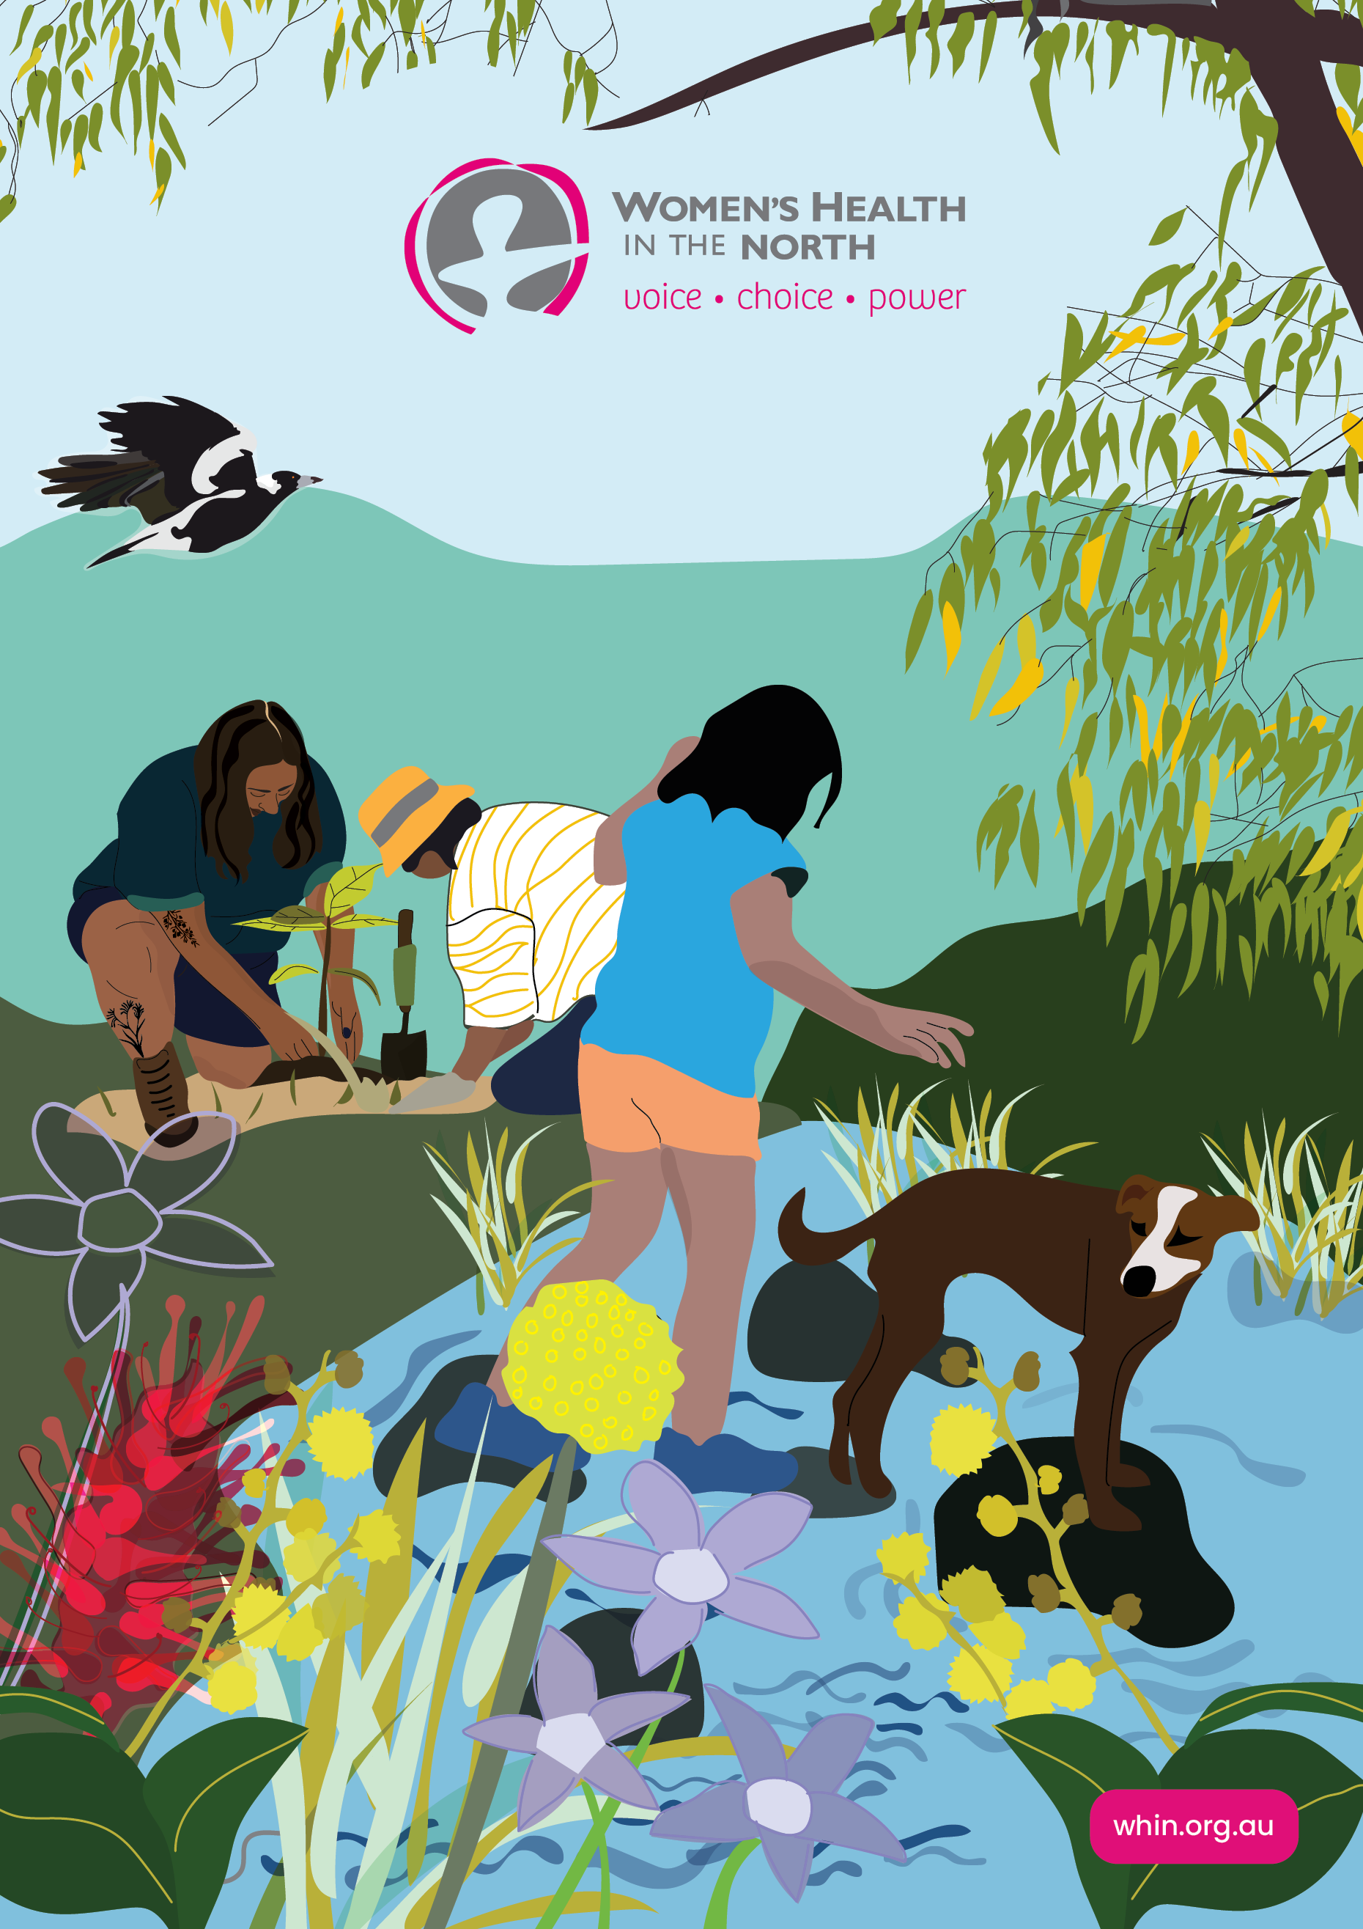ANNUAL REPORT  
2023–24

# Acknowledgements

WHIN would like to acknowledge our funding bodies:

* Department of Health, Victoria
* Department of Family, Fairness and Housing, Victoria
* Department of Social Services, Australian Government
* Ecstra Foundation



Women’s Health In the North acknowledges the support of the Victorian Government.

© Women’s Health In the North (2024)

This report and all its components (including formulas, data, images and text) are copyright. Apart from fair dealing for the purposes of research, planning or review as permitted under the Copyright Act 1968, no part may be reproduced, copied or transmitted in any form or by any means (electronic, mechanical or graphic) without the prior written permission of WHIN.

All requests and enquiries concerning reproduction and rights should be directed to the Manager of Corporate Services, WHIN.

The 12 Women’s Health Services funded through the state government’s Victorian Women’s Health Program operate under the title ‘Victorian Women’s Health Services Network’ (WHSN). Visit the [WHSN website](https://www.whsn.org.au). The WHSN drives and progresses women’s health and equality across nine regions and the state of Victoria. The network is a coordinated, mutually-reinforcing statewide network comprising both place-based and specialist services. See WHSN’s impact at [WHSN – A collective approach](https://www.whsn.org.au/a-collective-approach).

Donate to WHIN at the [WHIN website](https://www.whin.org.au/).

Women’s Health in the North

Reg. No. A0026656G

**ABN** 724 189 216 51

(03) 9484 1666

[info@whin.org.au](mailto:info@whin.org.au)

[www.whin.org.au](https://www.whin.org.au)

680 High Street, Thornbury  
VIC 3071, Australia

PO Box 1090, Thornbury, 3071

 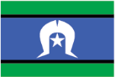

Women’s Health In the North acknowledges Victorian Aboriginal people as the Traditional Owners of the land on which we provide our services – the Wurundjeri Woi-wurrung people of the Kulin nation – and pay our respect to their Elders past, present and future. WHIN acknowledges that Aboriginal sovereignty was never given up and that we stand on stolen land. We are committed to Aboriginal self-determination and to supporting Treaty and truth-telling processes.

We recognise the ongoing leadership role of the Aboriginal community on gender equality and the health, safety and wellbeing of women and gender-diverse people. As First Peoples, Aboriginal Victorians are best placed to determine a culturally appropriate path to these in their communities.

This year’s Annual Report and cover image design by [Jacq Moon](http://www.jacqmoon.com).

Annual Report coordinated and edited by Claudia Slegers.

Contents

Acknowledgements 2

Our Vision 5

The Northern Metropolitan Region of Melbourne 6

Chair and CEO Report 7

WHIN’s Priorities and Initiatives 9

Our Impact 10

Informing Community and Workforces: Our Resources 14

Gender Equity, Health and Wellbeing 16

Preventing Gender-Based Violence 18

Sexual and Reproductive Health (SRH) 20

Family and Reproductive Rights Education Program 23

Economic Equality 25

Family Violence System Leadership 27

A Strong, Sustainable Organisation 29

Our Organisational Structure 31

Financial Reports for the Year Ended 30 June 2024 33

Independent Audit Report 33

Comprehensive Income Statement 35

Balance Sheet 36

Statement of Change of Equity 37

Statement of Cashflows 38

Responsible Persons’ Statement 39

WHIN Training and Consultancy Services 40

WHIN Contact Details 41

# Our Vision

## Mission

WHIN works to eliminate gender inequalities and improve the health, safety and wellbeing of women and gender-diverse people.

## Values

Feminist. Ethical. Inclusive. Courageous. Collaborative.

## Vision

Women and gender-diverse people in the north have voice, choice and power in all aspects of their health, safety and wellbeing.

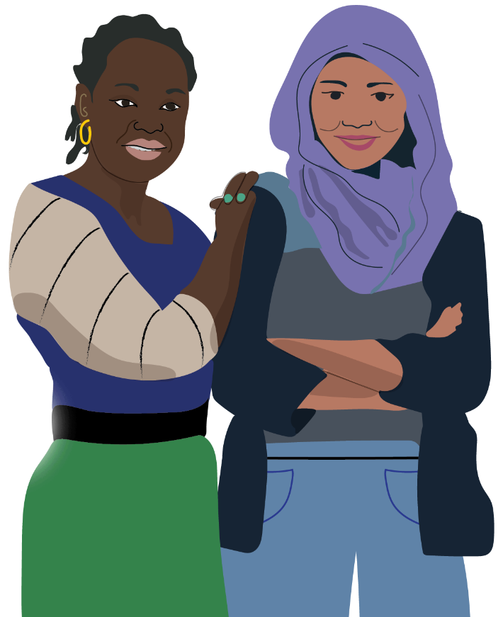

WHIN would like to acknowledge and thank the many partner organisations that we have worked with in this reporting period. These partnerships are integral to WHIN being able to improve the health, safety and wellbeing of women and gender-diverse people in Melbourne’s northern metropolitan region.

# The Northern Metropolitan Region of Melbourne

Land of Traditional Owners the Wurundjeri Woi-wurrung.

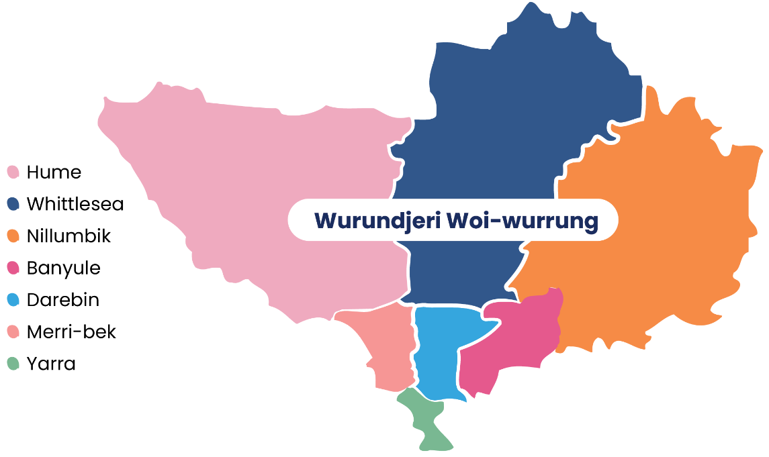

**Over 544,500** women and gender-diverse people live in WHIN’s catchment area, the northern metropolitan region (NMR) of Melbourne (Australian Bureau of Statistics 2022, Census figures).

**The region covers over 1,600 square kilometres from inner city parts of Richmond to remote reaches of Kinglake Ranges and Sunbury.**



Aboriginal and Torres Strait Islander Australians number 8,426 people in this region, approximately 51% of whom are female (approx 4,262)

(ABS 2022, Census figures).

Nearly half of all women and girls living in the NMR speak a language other than English at home, including: ***Arabic, Assyrian and Persian, Greek, Italian, Mandarin, Punjabi, Urdu, and Vietnamese***

(State of Victoria, Mapping Languages Spoken in Victoria, 2023).

# Chair and CEO Report

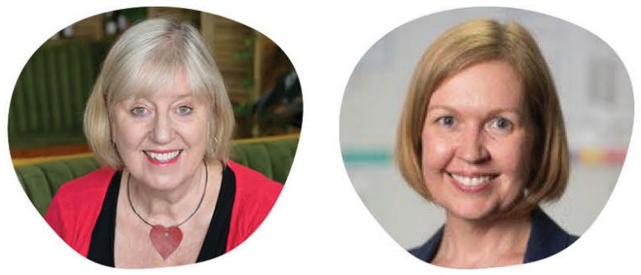

From left to right: Helen Riseborough and Petra Begnell

****We are proud to present WHIN’s annual report 2023–24 to you — our members, supporters, and partners. The annual report represents an incredible body of work aimed at eliminating gender inequalities and improving the health, safety and wellbeing of women and gender-diverse people in our region.****

WHIN’s priorities and programs serve the northern metropolitan area of Melbourne, our region.

We are a proud member of the Women’s Health Services Network of Victoria (WHSN). With our colleague organisations and allies in advocacy, our combined effort has seen the continued funding commitment by the Victorian state government to the Women’s Health Services across the state. The outcomes of this essential funding are demonstrated in this report.

WHIN thanks our supporters, members, partners, politicians and government, who continue to believe in the effectiveness of primary prevention, gender equality and the rights and health of all Victorians.

We acknowledge that there are still so many barriers and challenges to gender equality. The health and rights of women and gender diverse people are of primary importance to WHIN and we will continue to strive for equality in all we do.

We value your ongoing support and commitment.

Thank you.

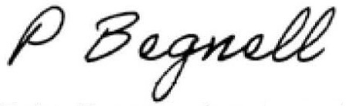

Petra Begnell, Board Chairperson

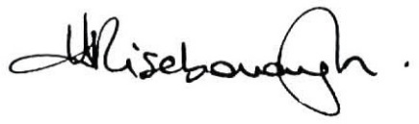

Helen Riseborough, CEO

# WHIN’s Priorities and Initiatives

Gender Equity, Health and Wellbeing

Preventing Gender-Based Violence

Family Violence System Leadership (NIFVS[1])

Economic Equality

Sexual and Reproductive Health

# Our Impact

## Highlights

Leadership and Governance of **8 Strategic Partnerships**, including:

* Building a Respectful Community Partnership: **28 organisations working together** to prevent gender-based violence across the NMR
* **NIFVS Family Violence Regional Integration Committee** to advance family violence system leadership
* **NIFVS Counselling and Support Alliance**, comprising community health and specialist family violence services, providing counseling and group work to over 500 victim survivors
* Women’s Health Services Network’s **(WHSN) Social Media Advocacy Working Group** for sexual and reproductive health advocacy
* **Student-led Gender Equality Pilot Working Group** with the Department of Education, cohealth and Neighbourhood Justice Centre
* **‘Taking ACtion’ Youth Action Group:** supporting young people to understand affirmative consent
* **Engaging Men in Preventing Gender-Based Violence** (PGBV) **Community of Practice**

## By the numbers

* 146 **Training / Education sessions** delivered by WHIN staff
* 2,027 **participants** attended WHIN training/education sessions
* 21 **events** held with 826 attendees including WHIN’s signature International Women’s Day event and film screening
* 333 **WHIN members**

## Newsletters

* 965 people received 12 editions of WHIN e-News
* 2,498 people received 8 editions of NIFVS e-News
* 111 people received 9 editions of SRH e-News
* 94 people received 5 editions of the (brand new!) BRC Bulletin.

## Online

* 2,875 WHIN Facebook followers
* 14,239 people visited WHIN’s website
* 45 WINC* Facebook followers
* 1,994 WHIN LinkedIn followers
* 44,472 people visited NIFVS’ website
* 1,582 Economic Equality website visits[2]
* 1,374 WHIN Instagram followers
* 87 NIFVS LinkedIn followers[3]

## Submissions

Made **submissions** to 13 inquiries and consultations, including:

* National Framework for Respectful Relationships Education
* Inquiry into Financial Services Regulatory Framework in Relation to Financial Abuse
* Our Watch’s ‘Men and Masculinities in Primary Prevention National Consultation’
* Inquiry into Issues related to Menopause and Perimenopause: WHIN submission and contribution to WHSN joint submission. WHIN also appeared before the Senate Committee to speak to this submission in June 2024
* Department of Health in relation to Victorian Auditor General’s Office recommendations on SRH service access in Victoria
* International Student Sexual Health Network Statement in relation to Overseas Health Cover Deed Revision in May 2024
* Department of Health and Assisted Reproductive Treatment Law Reform Team with the perspective of Rainbow Families

## Conferences and forums

12 external conference/forum presentations delivered

## Consultations

319 consultations conducted with individuals and organisations across the region

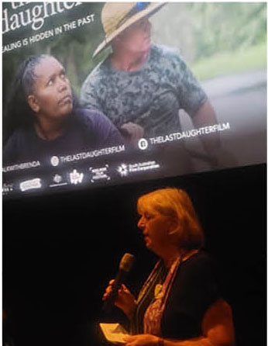

CEO Helen Riseborough speaking at WHIN’s International Women’s Day event and screening of The Last Daughter.

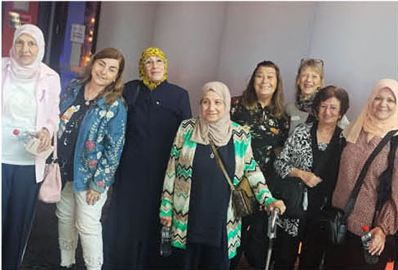

WHIN members and supporters at the screening

# Informing Community and Workforces: Our Resources

22 resources produced,  
downloadable from [WHIN’s resources webpages](http://www.whin.org.au/resources)

* [Engaging Men in the Prevention of Gender-Based Violence:](chrome-extension://efaidnbmnnnibpcajpcglclefindmkaj/https:/www.whin.org.au/wp-content/uploads/sites/2/2023/12/Engaging-men-in-the-Prevention-of-Gender-Based-Violence-Final-Draft-7.12.23.pdf)A Community of Practice that Supports the Work and the Workers
* 16 Days of Activism Social Media Toolkit (scroll down) [Women’s Health In the North | Preventing Gender-Based Violence Resources (whin.org.au)](https://www.whin.org.au/resources/preventing-gender-based-violence/)
* Contributed a piece on sexual and reproductive rights to [1800 My Options SEXtember Zine 2023](https://www.1800myoptions.org.au/information/sextember-zine)
* Re-print of [Sex Ed 101](https://www.whin.org.au/resources/sexual-and-reproductive-health-resources/) picture book
* **Podcast/Radio recordings:**
  + [Well, Well, Well Sexual and Reproductive Health Month](https://joy.org.au/wellwellwell/2023/09/sexual-health-month-with-womens-health-in-the-north/) – Thorne Harbour Health, Joy FM
  + [Young Women’s Business: Sexual and Reproductive Health](https://soundcloud.com/3knd/nephu-ep-4-young-womens-business-part1-fe) – 3KND Radio Interview Part 1 and Part 2.
* 5 social media campaigns developed collaboratively with other women’s health services for Sexual and Reproductive Health Week, World Condom Day, International Day of Women Living with HIV, Endometriosis Awareness Month, and IDAHOBIT
* [Economic Equality Website](https://economicequality.org.au/), recently launched
* [Economic Equality Discussion Paper](https://economicequality.org.au/wp-content/uploads/2024/04/economic-equality-discussion-paper-web-compressed.pdf)
* [Budgeting and Saving Skills Scoring Test](https://economicequality.org.au/skills-scoring-test/)
* [Debt Assessment Tool](https://economicequality.org.au/debt-assessment-tool/)
* 2021–2023 [Evaluation Report](https://economicequality.org.au/wp-content/uploads/2024/04/LTM-Evaluation-Report.pdf) for the ‘Let’s Talk Money’ Program
* [Working with Aboriginal Community Members Experiencing Family Violence:](https://www.nifvs.org.au/2024/07/15/new-resource-working-with-aboriginal-community-members-experiencing-family-violence/) Tip sheet for practitioners. In collaboration with VACCA (Victorian Aboriginal Child and Community Agency)

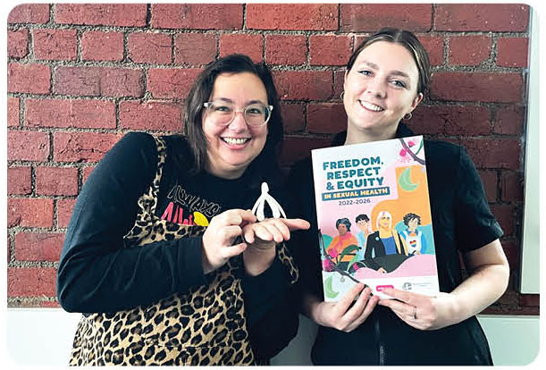

Sexual and Reproductive Health Coordinator Tilly Mahoney holding the SRH Strategy, with Health Promotion Officer Amelia Arnold at far left.

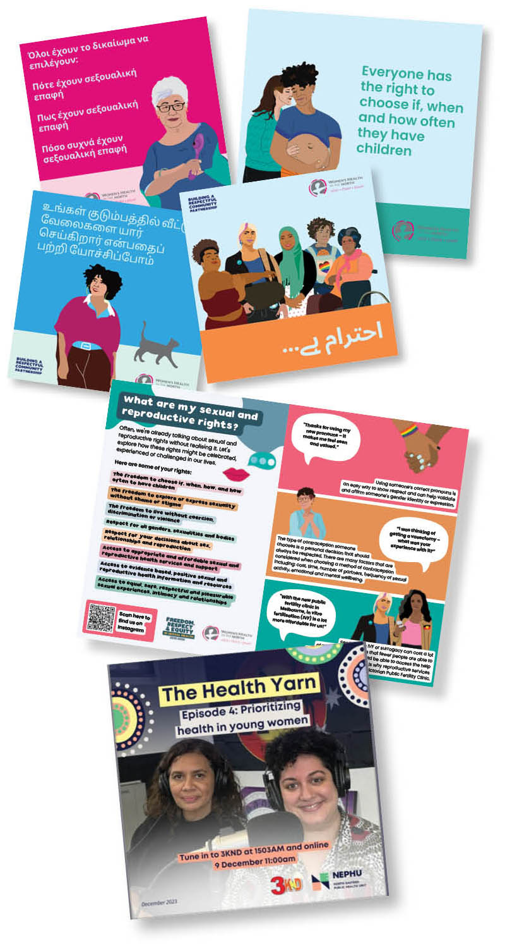

# Gender Equity, Health and Wellbeing

## This year, we

* co-led ‘Student-led Gender Equality Pilot’ program with the Department of Education. This involved capacity building and co-design workshops with Grade 6 students at a local primary school so they can plan and implement their own school-based gender equity projects
* collaborated with Women’s Health East to deliver a capacity building program for North Eastern Public Health Unit (NEPHU) to support staff to conduct gender impact assessments on their public health plans and initiatives
* co-led the Hume Gender Equality in Sport Network, together with DPV Health and Hume City Council. This has strengthened relationships between the three organisations and created a space for shared learning through guest speaker presentations, best practice frameworks, and workshopping ideas
* contributed to Action for Gender Equality Partnership to develop a coordinated approach to organisational and workforce development strategies for implementing the *Gender Equality Act 2020 (Vic)*.

## By the numbers

* 31 **training sessions delivered to** 396 **participants**, including gender impact assessment training to organisations
* 100+ **WHIN members** attended WHIN’s signature International Women’s Day event, ‘Women’s Health In the North go to the Movies’

## Leadership and Governance

* convened and led Student-led Gender Equality Pilot Working Group with the Department of Education, cohealth and Neighbourhood Justice Centre
* co-led Hume Gender Equity in Sport Network with Hume City Council and DPV Health

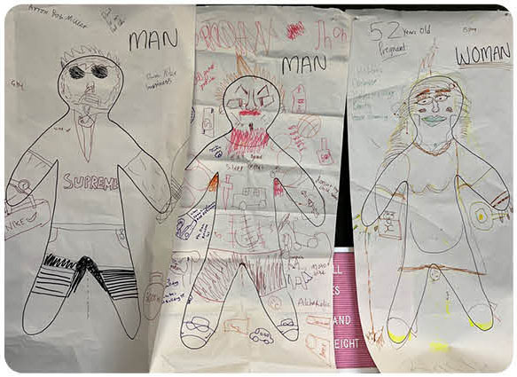

Grade 6 student drawings produced as part of ‘Student-led Gender Equality Pilot’ program

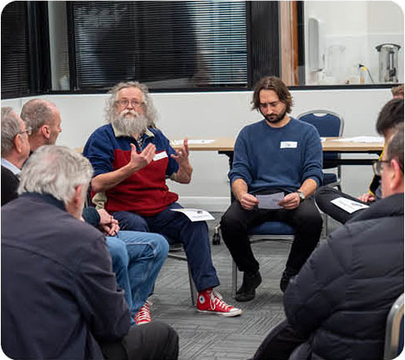

Colleagues and community members from Merri-bek City Council gather to talk about things men can do to challenge sexism, as part of the ‘Courageous Conversations’ forums.

## More information

See our [Gender Equity webpage](https://www.whin.org.au/what-we-do/gender-equity-health-and-wellbeing) for more information.

www.whin.org.au/what-we-do/gender-equity-health-and-wellbeing

# Preventing Gender-Based Violence

## This year, we

* convened the ‘Taking ACtion’ Youth Action Group in partnership with Banksia Gardens Community Services, developed youth capacity to co-design and deliver peer education and engagement initiatives to understand affirmative consent
* delivered the ‘Allyship in Action’ Forum with Zoe Belle Gender Collective to enhance prevention practitioners’ ability to prevent violence against trans and gender-diverse individuals through bystander intervention
* worked with Building a Respectful Community (BRC) partners City of Whittlesea and DPV Health to deliver the ‘Respect, Empower and Celebrate Women’ wellbeing day to 88 migrant and refugee women. The event received funding from Safe and Equal and Respect Victoria’s 16 Days of Activism Grassroots Initiative
* supported strategic planning of the BRC through a mid-strategy action planning workshop to identify opportunities to collaborate across partner organisations for shared objectives
* developed and launched the BRC Bulletin e-newsletter to share information about BRC activities, as well as events, resources and trainings from the primary prevention sector to foster connection within the Partnership.

## By the numbers

* 18 **training sessions** delivered to **187** participants
* developed and hosted 15 **events** for 380 attendees

## Submissions

* Made 3 **submissions** plus participated in 3 consultations, including:
  + Our Watch’s Men and Masculinities in Primary Prevention National Consultation
  + National Framework for Respectful Relationships Education
  + Inquiry into Financial Services Regulatory Framework in Relation to Financial Abuse.

## Leadership and Governance

Convened, led and resourced:

* Building a Respectful Community Partnership: 28 organisations working together to prevent gender-based violence across the NMR
* ‘Taking ACtion’ Youth Action Group
* Engaging Men in Preventing Gender-Based Violence Community of Practice to support prevention work and workers in partnership with City of Whittlesea.

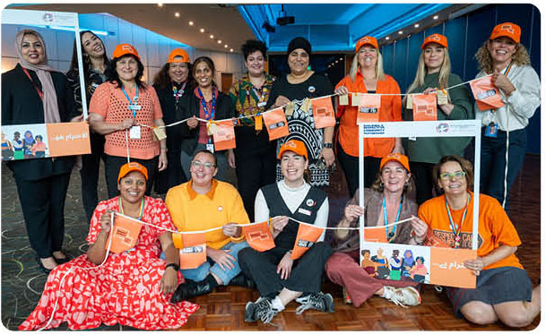

WHIN, DPV Health, City of Whittlesea and Sikh Community Connections staff at the ‘16 Days of Activism event’.

## More information

See our [Preventing Gender-Based Violence webpage](https://www.whin.org.au/what-we-do/preventing-gender-based-violence) for more information.

www.whin.org.au/what-we-do/preventing-gender-based-violence

# Sexual and Reproductive Health (SRH)

## This year, we

* facilitated a panel discussion called ‘Can I Ask That? Meaningful engagement of LGBTIQA+ young people in sexual and reproductive health’ at ASHM Australian SRH Conference, which engaged more than 120 attendees
* appeared before the Senate Committee for Community Affairs - References Committee to speak to WHIN’s submission to the Inquiry into the Issues related to Menopause and Perimenopause
* delivered the ‘Inclusive and Affirming Fertility Care Training Project’ to all staff at the Victorian Public Fertility Service to build capacity to work in a safe, accessible and affirming way with LGBTIQA+ people, migrant, multicultural and multifaith groups, and people with disabilities.

## By the numbers

14 **workshop sessions** delivered providing SRH information to a total of 187 participants

## Submissions

Made **5 submissions** to inquiries and consultations, including:

* inquiry into Issues related to Menopause and Perimenopause: WHIN submission and contribution to WHSN joint submission
* endorsed the International Student Sexual Health Network Statement in relation to Overseas Health Cover Deed Revision in May 2024
* 8 presentations to conferences and external forums
* provided 142 consultations about projects, programs and plans to a range of organisations including Victorian Department of Health, Northern Hospital and Royal Women’s Hospital, universities, and community health services.

## ****Leadership and Governance****

* chaired and convened the WHSN Social Media Advocacy Working Group in relation to sexual and reproductive health
* contributed to the broader WHSN SRH Community of Practice
* contributed to 7 other advisory/working groups, including NEPHU SRH Program Control Group, associated System Enhancement Working Group, International Students Sexual Health Network, and Women’s Mental Health Alliance

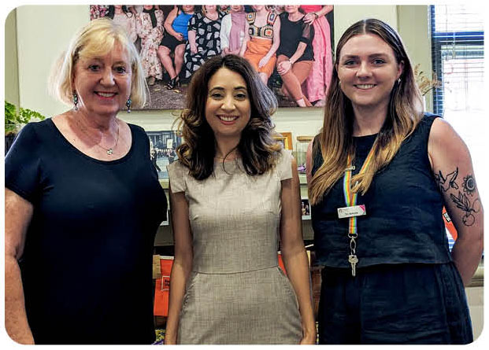

CEO Helen Riseborough (left) and Coordinator, SRH Tilly Mahoney (right) welcoming Kat Theophanous MP to WHIN’s Office.

‘It is invaluable to have spaces for trans and gender-diverse people … for us to discuss these sorts of issues. Trans people have unique challenges with our sexual expression and experiences, but also unique opportunities. Having a trans expert support this knowledge sharing and reflective space was so valuable. I am very grateful.’

Participant, Trans Equity in SRH – Community Workshop Series

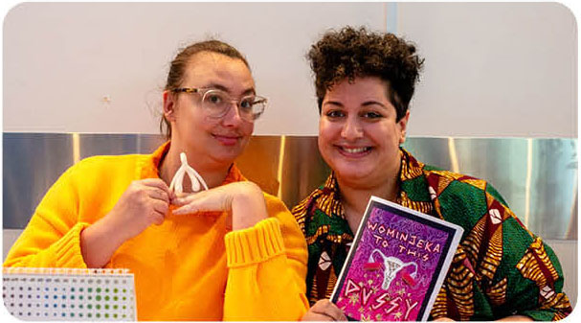

WHIN Health Promotion Officers Amelia Arnold (left) and Heti Mackallah (right) at a community-facing event providing resources and information to women and gender-diverse people.

## More information

See our [SRH Sexual and Reproductive Health webpage](https://www.whin.org.au/current-work/sexual-and-reproductive-health) for more information.

www.whin.org.au/current-work/sexual-and-reproductive-health

# Family and Reproductive Rights Education Program

## This year, we

* presented at Public Health Association Australia’s Preventive Health Conference in Darwin on community-led prevention of female genital cutting (FGC)
* delivered 3 professional development sessions about refugee women’s health and FGC to 40 community service and health professionals
* provided 177 one-on-one phone/Zoom consultations and needs analyses with members of communities that traditionally practise FGC
* delivered ‘Side by Side’ program to two community groups. ‘Side by Side’ is a culturally responsive sexual and reproductive health and respectful relationships program for women from communities that traditionally practice FGC.

‘Very informative session and useful contact list about where to go for cultural appropriate health services for women who have experienced FGC.’

‘Side by Side’ participant

## By the numbers

16 **education sessions** delivered to 188 participants, including health professionals, women who have experienced FGC, and women from communities that traditionally practise FGC

## Partnerships

Contributed to:

* development of statewide shared indicator framework for FARREP through consultation with the Department of Health
* North West FARREP Partnership Governance Group and Worker’s Network, taking on the role of conduit in 2024.

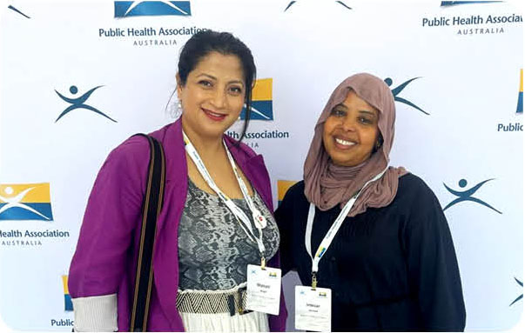

Health Promotion Officer Intesar Homed (right) and Manager, Economic Equality Manasi Wagh (left) at the Preventive Health Conference 2024.

# Economic Equality

This year we established an Economic Equality Team to underline our commitment to addressing the intersection of economic inequality and gender as a determinant of health outcomes. The work of this team will include extending our long-established and successful ‘Let’s Talk Money’ program.

## This year, we

* delivered an ‘Economic Equality Forum’ with a range of stakeholders across the financial capability and wellbeing sector
* developed and launched our Economic Equality website, incorporating ‘Let’s Talk Money’. For more information, see: www.[economicequality.org.au](https://economicequality.org.au/)
* redeveloped our ‘Let’s Talk Money’ financial literacy program as a Train-the-Trainer program for women’s health staff across Victoria to deliver the program within their own communities. This training was initially introduced to inner metropolitan women’s health services staff
* continued to deliver bilingual financial literacy workshops to community members
* developed ‘Mind and Money’, a community education module, focusing on the link between financial wellness and mental health
* Manasi Wagh, Manager of Economic Equality and developer of WHIN’s ‘Let’s Talk Money’ program, was inducted into the Victorian Honour Roll of Women, 2023.

## By the numbers

* **delivered** 27 training workshops to **477 participants**, including community members and women’s health services staff as part of the Train-the-Trainer sessions
* **hosted** 2 **events** for 103 participants
* 4 conference and forum presentations

## Submissions

**Contributed to** WHIN’s submission to the Inquiry into Financial Services Regulatory Framework in Relation to Financial Abuse

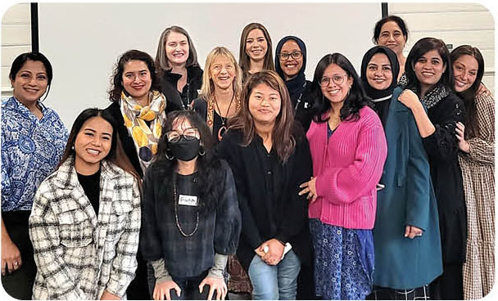

Staff from GenWest, Women’s Health in the South East and Women’s Health East participate in the ‘Let’s Talk Money’ Train-the-Trainer program

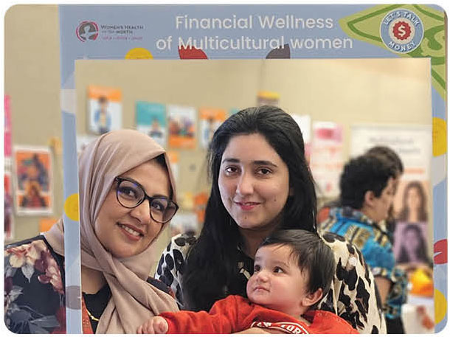

WHIN’s ‘Let’s Talk Money’ Educator Attia Rana and a participant and her child, pose holding a selfie frame

## More information

See our [Economic Equality website](https://www.economicequality.org.au), incorporating ‘Let’s Talk Money’, for more information.

www.economicequality.org.au

# Family Violence System Leadership

**The Northern Integrated Family Violence Services (NIFVS) provides family violence system leadership across Melbourne’s NMR. Operating through the Regional Integration Committee, NIFVS works to increase the safety of victim survivors, hold people who use violence to account, and implement Victoria’s family violence reforms.**

**More information is available on the** [NIFVS website](https://www.nifvs.org.au)**:** www.nifvs.org.au

## This year, we

* conducted the ‘Building Bridges’ forum which brought together sector partners to improve understanding of the work being conducted across the region. This included services working with people who use violence and those working with victims of family violence
* designed the 2023 ‘NIFVS MARAM[4] Workforce Alignment and System Integration Survey’, the first of an annual survey to establish a baseline for the collection of regional workforce data. Data collection from practitioners working in MARAMIS prescribed organisations monitors how reform is progressing in the region and whether it is improving family violence response practice
* developed a comprehensive program logic and Annual Action Plan to inform all activities undertaken by the FVRIC
* adopted a new governance structure which has seen a newly elected Leadership Group in situ effective as of 1 July 2024. The General Membership Committee will see a broadening of organisational representation across the region
* developed Working with Aboriginal Community Members Experiencing Family Violence: Tip sheet for practitioners, as part of recommendations for the Victim Survivor Mapping Project in collaboration with VACCA

## By the numbers – Training and events

* delivered 40 training and education sessions to 592 family violence practitioners. including ‘MARAM Collaborative Practice’ training
* Conducted 2 **events** for 123 family violence professionals
* 1,927 views of 2 NIFVS webinars including ‘Introduction to Family Violence Response’.

## Leadership and Governance

* led, convened and resourced the **Family Violence Regional Integration Committee** to advance family violence system leadership
* coordinated, supported and monitored **NIFVS Counselling and Support Alliance**, comprising 13 community health and specialist family violence services, providing counseling and group work to over 500 victim survivors
* NIFVS Principal Strategic Advisor sat on the Secretariat for the **Statewide Family Violence Integrated Advisory Committee.**

# A Strong, Sustainable Organisation

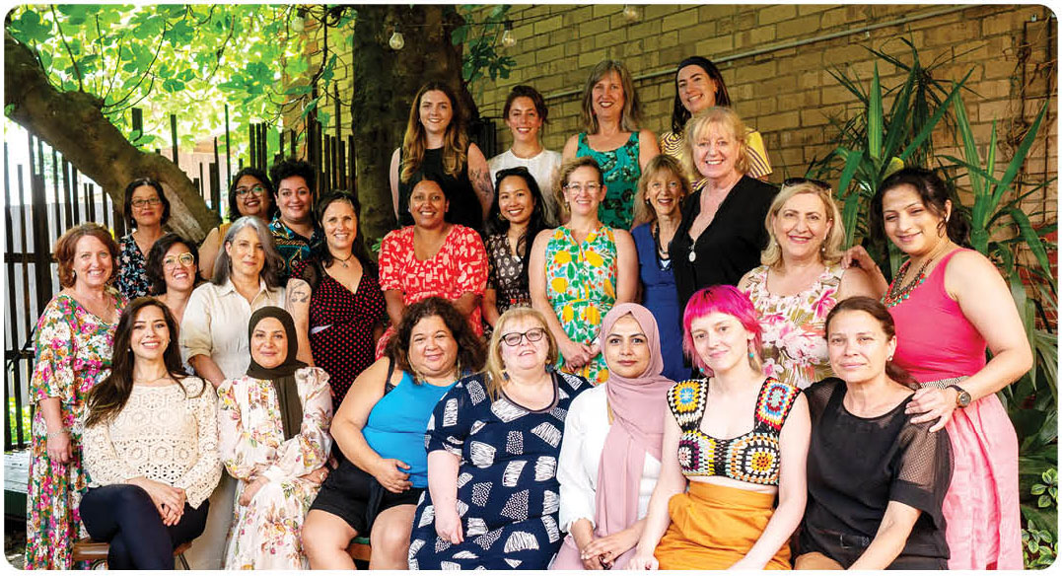

## This year, we

* contributed to Women’s Health Services Network Queen’s Hall showcase event which saw all Women’s Health Services come together to meet with Victorian MPs and discuss our work. Over 50 Ministers and MPs signed a pledge to support women’s health and wellbeing, with signatories including Premier Jacinta Allan and Minister for Health Mary-Anne Thomas
* contributed to WHSN state-wide collective impact evaluation. WHIN presented the findings of this evaluation at a national public health conference on behalf of the WHSN
* launched our first Reconciliation Action Plan
* established the Economic Equality team, which will focus on building gender equality through economic empowerment
* developed a *Mental Health and Wellbeing: NMR factsheet* which was launched at the 2023 WHIN AGM
* established an internal system to embed an intersectional feminist approach to all of WHIN’s work
* coordinated and undertook all-staff disability inclusion training to enable staff to apply a disability and gender lens to programs and services at WHIN
* finalised negotiations and produced a new WHIN Employment Agreement
* completed transition from local server data management to cloud-based system via Sharepoint, and decommissioned WHIN’s local file server
* streamlined financial operations by realigning of roles.

# Our Organisational Structure

## ****WHIN’s Board of Governance****

**Katherine Wositzky**Chair until October 2023. Coopted from November 2023.

**Petra Begnell**Chair from November 2023 (on the Board since Oct 2022)

**Tanya Stelmach**Deputy Chair from November 2023 (on the Board since Oct 2018)

**Karen Huxley**Treasurer until February 2024 (resigned)

**Karen Jones**Treasurer – from February 2024 (on the Board since Oct 2022)

**Kristen Boulton**from October 2023

**Helen Coleman**from October 2023

**Lauren Cordwell**until October 2023

**Lucy Forwood**

**Yasmin Karaata**

**Phoebe Prossor**until October 2023

**Tanya Stelmach**

**Cara Rose**from October 2023

## Staff

**Helen Riseborough**  
Chief Executive Officer

Administrative Officer and Executive to the CEO

Corporate services:

* Manager
* Finance Officers
* Administration Officers

NIFVS:

* Principal Strategic Advisor
* MARAMIS and Workforce Development Coordinator
* Communications and Project Officer

Economic Equality:

* Manager
* Financial Capability Coordinator
* Health Promotion Officers
* Peer Educator

Strategic Partnerships and Health Promotion:

Manager

* **Communications:**
  + Coordinator
  + Communications Officer
* **Gender Equity and Preventing Gender-Based Violence:**
  + Coordinator
  + Health Promotion Officers
* **Sexual and Reproductive Health:**
  + Coordinator
  + Health Promotion Officers

# Financial Reports for the Year Ended 30 June 2024

Independent Audit Report

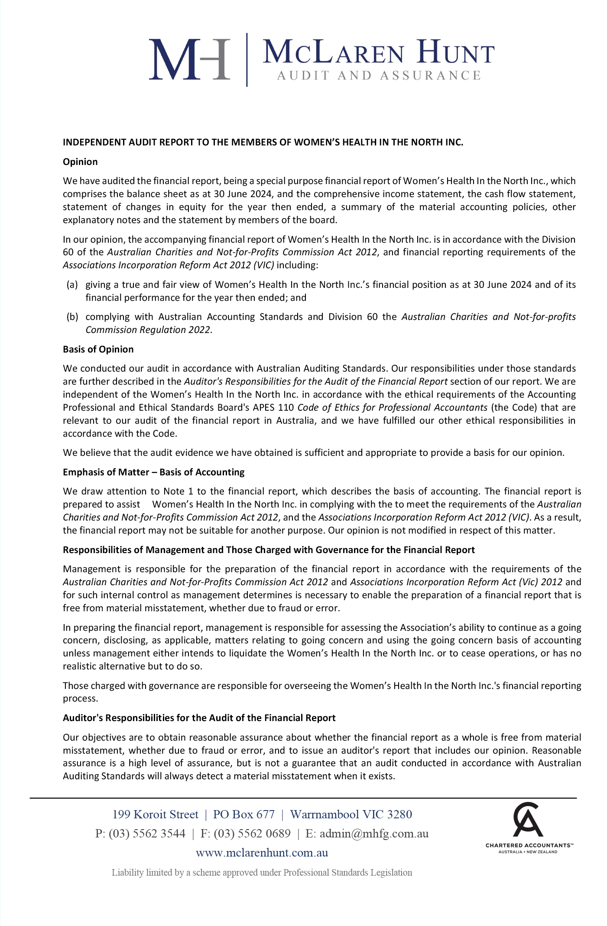

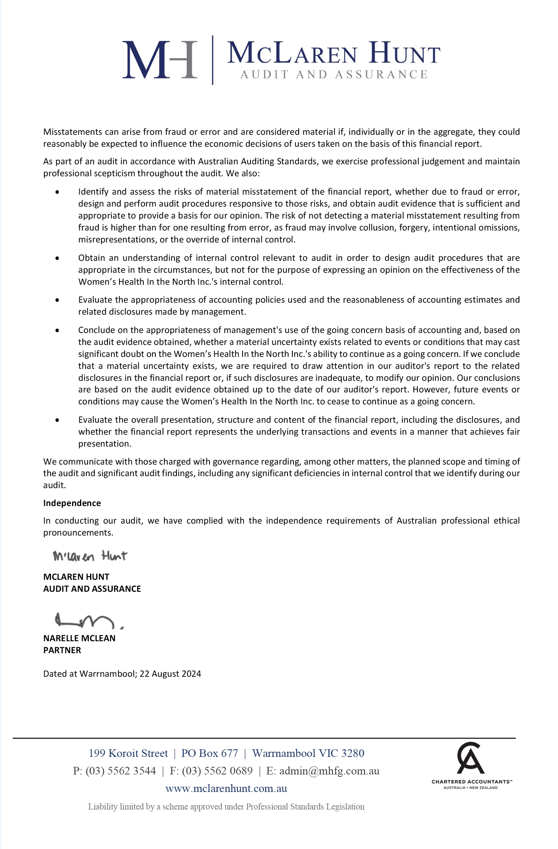

Comprehensive Income Statement

for the Year Ended 30 June 2024

|  | 2024  $ | 2023  $ |
| --- | --- | --- |
| Income | | |
| Dept of Health/ Department of Families, Fairness and Housing | 3,179,617 | 2,936,972 |
| Special Projects | 652,060 | 706,899 |
| Interest Received | 74,906 | 39,537 |
| Other | 71,380 | 128,920 |
|  | 3,977,963 | 3,812,328 |
| Expenditure | | |
| Employee Benefits Expense | 2,628,472 | 2,343,541 |
| Project Costs | 720,752 | 710,832 |
| Consultancy Fees | 170,377 | 250,902 |
| Administration | 101,832 | 93,097 |
| Occupancy Costs | 105,392 | 31,440 |
| Interest Expense | - | 1,426 |
| Depreciation and Amortisation | 24,536 | 89,707 |
| Motor Vehicle Expenses | 11,494 | 10,738 |
| Printing & Production | 30,318 | 28,542 |
| Health Education Resources | 2,764 | 4,167 |
|  | 3,795,937 | 3,564,392 |
| Comprehensive Result | 182,026 | 247,936 |

Balance Sheet

As at 30 June 2024

|  | 2024  $ | 2023  $ |
| --- | --- | --- |
| Assets |  |  |
| Current Assets | | |
| Cash and Cash Equivalents | 1,578,523 | 1,472,943 |
| Trade and Other Receivables | 121,469 | 81,827 |
| Financial Assets | 1,200,000 | 1,200,000 |
|  | 2,899,992 | 2,754,770 |
| Non-Current Assets |  |  |
| Plant and Equipment | 21,442 | 44,309 |
|  | 21,442 | 44,309 |
| Total Assets | 2,921,434 | 2,811,076 |
| Liabilities | | |
| Current Liabilities | | |
| Trade and Other Payables | 251,790 | 271,231 |
| Other Liabilities | 308,735 | 329,196 |
| Leave Entitlements | 373,965 | 357,625 |
|  | 934,490 | 1,021,052 |
| Non Current Liabilities | | |
| Leave Entitlements | 30,295 | 15,401 |
|  | 30,295 | 15,401 |
| Total Liabilities | 964,785 | 1,036,453 |
| Net Assets | 1,956,649 | 1,774,623 |
| Equity | | |
| Retained Earnings | 1,956,649 | 1,774,623 |
| Total Equity | 1,956,649 | 1,774,623 |

Statement of Change of Equity

For the Year Ended 30th June 2024

|  | 2024  $ | 2023  $ |
| --- | --- | --- |
| Total Equity at the Beginning of the Financial Year | 1,774,623 | 1,526,687 |
| Comprehensive Result | 182,026 | 247,936 |
| Total Equity at the End of the Financial year | 1,956,649 | 1,774,623 |

Statement of Cashflows

For the year ended 30 June 2024

|  | Note | 2024  $ | 2023  $ |
| --- | --- | --- | --- |
| Cash Flow From Operating Activities | | | |
| Receipts from Government grants (Recurrent) |  | 3,405,771 | 3,172,526 |
| Receipts from other sources |  | 765,375 | 983,866 |
| GST received/(paid) |  | (276,578) | (252,802) |
| Payments to suppliers and employees |  | (3,862,225) | (3,256,395) |
| Interest received |  | 74,906 | 39,537 |
| Net cash provided by (used in) operating activities (Note 2) |  | 107,249 | 686,732 |
| Cash Flow From Investing Activities | | | |
| Payments for plant, equipment and motor vehicles |  | (1,669) | (21,084) |
| Proceeds from sale of plant, equipment and motor vehicles |  | - | - |
| Proceeds from (payment for) investments |  | - | - |
| Net cash provided by (used in) investing activities |  | (1,669) | (21,084) |
| Cash Flow from Financing Activities | | | |
| Net movement in lease liability |  | - | (65,411) |
| Net cash provided by (used in) financing activities |  | - | (65,411) |
| Net increase (decrease) in cash held |  | 105,580 | 600,237 |
| Cash at beginning of year |  | 1,472,943 | 872,706 |
| Cash at end of reporting period (Note 3) | 10 | 1,578,523 | 1,472,943 |

Responsible Persons’ Statement

As at 30 June 2024

### Declaration

The financial statements forming part of this document fairly present the organisation's financial position at 30th June 2024 and its performance for the year ended on that date in accordance with the Australian Charities and Not-for-profits Commission Act 2012, and:

1. comply with Australian Accounting Standards; and
2. give a true and fair view of the financial position of the entity as at 30th June 2024 and of its performance for the year ended on that date; and
3. the financial statements satisfy the requirements of the Australian Charities and Not-for-profits Commission Act 2012.

There are reasonable grounds to believe that the organisation will be able to pay its debts as and when they become due and payable.

This declaration is signed in accordance with subs 60.15(2) of the Australian Charities and Not-for-profits Commission Regulation 2013.

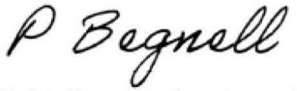

Petra Begnell  
Chairperson

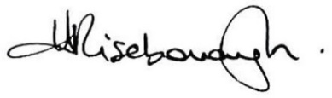

Helen Riseborough  
Chief Executive Officer

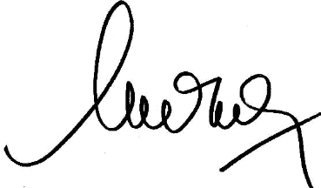

Adriana Uteda  
Manager, Corporate

# WHIN Training and Consultancy Services

WHIN offers a range of training, as featured in our Training and Consultancy Services Brochure. Or we can develop a training and consultancy package to meet your organisation or group’s needs.

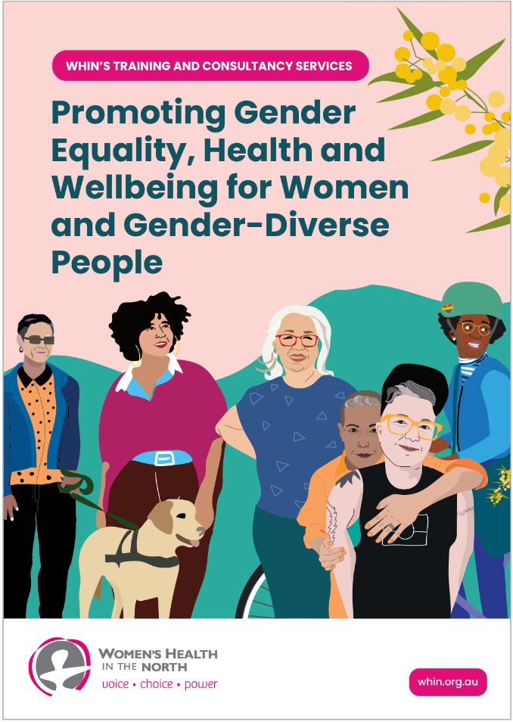

## Find out more

[](https://www.whin.org.au/training/training-modules)

**Download the brochure from the** [**WHIN Training Modules webpage**](https://www.whin.org.au/training/training-modules)**.**

www.whin.org.au/training/training-modules

To request a quote or find out more, please contact the WHIN training team by emailing [training@whin.org.au](mailto:training%40whin.org.au?subject=)

# Women’s Health in the North

Reg. No. A0026656G

**ABN** 724 189 216 51

(03) 9484 1666

[info@whin.org.au](mailto:info@whin.org.au)

[www.whin.org.au](https://www.whin.org.au)

680 High Street, Thornbury  
VIC 3071, Australia

PO Box 1090, Thornbury, 3071

[](https://www.facebook.com/whinmelbourne/) [WHIN on Facebook](https://www.facebook.com/whinmelbourne/)

[](https://www.linkedin.com/company/womens-health-in-the-north/) [WHIN on LinkedIn](https://www.linkedin.com/company/womens-health-in-the-north/)

[](https://www.instagram.com/womenshealthinthenorth/?hl=en) [WHIN on Instagram](https://www.instagram.com/womenshealthinthenorth/?hl=en)

1. Northern Integrated Family Violence Services
2. Women In the North Connect
3. Recently launched!
4. MARAM is ‘Multi-Agency Risk Assessment and Management Framework’.